Preparation Guide
Session2 Preparation Guide
Setting Up a Free Azure Account and a Free Jira Account for the RAG Agent Demo

Purpose
This guide walks you, the instructor, through building the demo environment from scratch before class, using only free-tier / free-trial accounts. No paid subscription is required to complete the demo. Total setup time: roughly 60–90 minutes.
Do this 2–3 days before class so you have buffer time for identity verification, quota approval, or model availability issues.Grant admin consent

What You Will End Up With
- An Azure subscription with $200 / 30-day free credit (first time sign-up account)
- One Resource Group containing: an Azure OpenAI resource (chat model + embedding model deployed) and an Azure AI Search service (Basic tier, vector + semantic search enabled)
- An optional Microsoft Entra ID App Registration (only needed if you demo the user-lookup / password-reset tool from the reference workflow)
- A Jira Cloud Free site with one project and an API token
- Working credentials pasted into n8n, tested end-to-end

Part A — Create the Azure Free Account
Refer to the youtube video : How to Run Your AI Agents For Free (Azure OpenAI & n8n Tutorial)

A.1 Prerequisites
- A phone number (for SMS verification)
- A credit or debit card — not a prepaid card. You will see a temporary $1 authorization hold, not a charge.
- A Microsoft account or GitHub account to sign in with
Note: One free account is allowed per person. If you already used a free trial in the past, sign up with a Microsoft account that has never had one, or use pay-as-you-go with a tight budget alert instead.

A.2 Sign Up
- Go to azure.microsoft.com/free and select "Start free."
- Sign in with a Microsoft or GitHub account.
- Complete identity verification (phone + card).
- Accept the agreement. Your subscription is created immediately.
- Confirm what you received: $200 credit valid for 30 days, plus a set of "always free" service quotas that do not expire.

A.3 Know Your Guardrails
Keep these numbers in your head while you build the demo — they are the difference between a free class and a surprise bill:
Item | Limit
Trial credit | $200, expires 30 days after signup
Azure AI Search — Basic tier | Consumes roughly one-third of the $200 credit if left running for the full 30 days
Azure AI Search — Free (F0) tier | $0 forever, but does NOT support semantic ranking — not usable for this course's semantic search requirement
After credit runs out / 30 days pass | You must switch to pay-as-you-go to keep resources running, or everything is disabled

Note: Set a budget alert immediately after signup: Cost Management + Billing → Budgets → Create → alert at $50 / $100 / $150. This is a 2-minute step that prevents surprises.

Part B — Create a Resource Group
A Resource Group is simply a labeled folder for everything you deploy. Deleting it deletes everything inside it in one action — this is your cleanup button after class.
- In the Azure Portal, search "Resource groups" → Create.
- Subscription: your free trial subscription.
- Resource group name: something like rg-rag-demo-classname.
- Region: choose a region where Azure OpenAI is available (e.g., East US)— availability varies by model, check the Azure OpenAI region list before picking one.
- Review + Create.
Note: Pick ONE region and use it for every resource below (OpenAI, AI Search). Cross-region calls add latency and, for some private-networking features, are not supported.

Part C — Deploy the LLM and Embedding Models (Azure OpenAI / Azure AI Foundry)
Refer to the Youtube video :🤔 How to Choose & Deploy the Right Model in Azure AI Foundry | Step-by-Step Tutorial

C.1 Request Access (if prompted)
In most subscriptions and regions, Azure OpenAI is now available instantly. In some regions or newly created tenants, you may see an access-request form the first time you create the resource. If so, submit it — approval is typically fast, but build in a buffer day before your class.

C.2 Create the Azure OpenAI Resource
- Portal → Create a resource → search "Azure OpenAI" → Create.
- Select your subscription, resource group, region, and a resource name.
- Pricing tier: Standard S0.
- Review + Create, then wait for deployment to finish.

C.3 Deploy Two Models in Azure AI Foundry
Open the resource → "Go to Azure AI Foundry portal" → Deployments → Create new deployment. Deploy two separate models:
- A chat / completion model (e.g., gpt-5-mini) — this is the model that reasons and answers questions
- An embedding model (e.g., text-embedding-3-small) — this is the model that converts text into vectors for search
Give each deployment a clear, short deployment name (e.g., gpt-5-mini, embed-3-small) — you will type this exact name into n8n later.

C.4 Collect Your Credentials
On the Azure OpenAI resource page → "Keys and Endpoint":
- Endpoint URL
- KEY 1 (or KEY 2 — either works)
- API version (shown in the Azure AI Foundry "View code" sample, e.g. 2024-10-21)
Note: Treat this key like a password. For a classroom demo, plan to rotate (regenerate) it after class.

Part D — Create the Azure AI Search Service
- Portal → Create a resource → search "Azure AI Search" → Create.
- Same subscription, resource group, and region as your OpenAI resource.
- Pricing tier: Basic (required for semantic ranking — the Free/F0 tier does not support it).
- Review + Create.
- Once deployed, open the resource → Settings → Settings → Premium features→ Semantic ranker → enable the Free plan (a limited number of semantic queries per month at no extra cost).
- Open Security + networking. → Keys → copy the Primary admin key and the URL (endpoint).
Important Note: Basic tier bills by the hour for as long as the service exists, even if you never send it a query. Don't create it until you're ready to start building — and delete it as soon as class is over (see Part H).

Part E — Network & Identity Configuration

E.1 For a Demo (Simple Path)
Leave both the Azure OpenAI resource and the Azure AI Search service on "Public access — All networks" (the default). This is the fastest path and is fine for a temporary demo with no production data.

E.2 What to Show as the Enterprise Pattern
In a real enterprise deployment, the resource group would instead use:
- Private Endpoints so traffic never leaves the Azure virtual network
- Network Security Groups / firewall rules restricting which IP ranges can reach the resource
- Managed Identity instead of API keys, so n8n (or an Azure-hosted service) authenticates without a secret ever being stored
- Role-Based Access Control (RBAC) — e.g., Cognitive Services OpenAI User role scoped to only the service principal that needs it

E.3 Microsoft Outlook Mail.Send (Ticket Notification Email Use Case)

Note: The Mail.Send permission is configured in
Azure Portal → Microsoft Entra ID → App Registration. It is NOT set anywhere in the Outlook web interface — Outlook is only the mailbox you sign in with, not where the permission lives.

1. Portal → Microsoft Entra ID → App registrations → register a App.
2. Authentication → Add a platform → Web → redirect URI: https://YOUR_N8N_DOMAIN/rest/oauth2-credential/callback

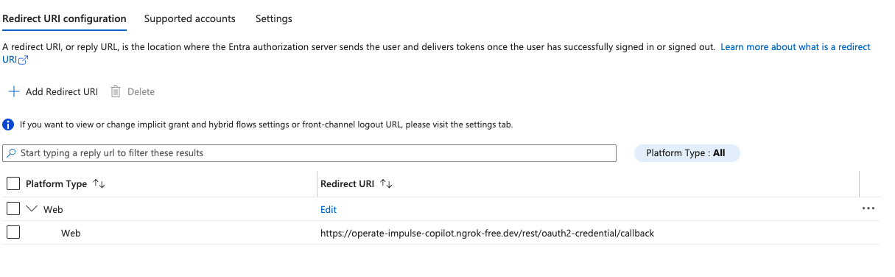
3. API permissions → Add a permission → Microsoft Graph → Delegated permissions → add Mail.Send (also recommended: Mail.ReadWrite, offline_access, User.Read) → Grant admin consent.
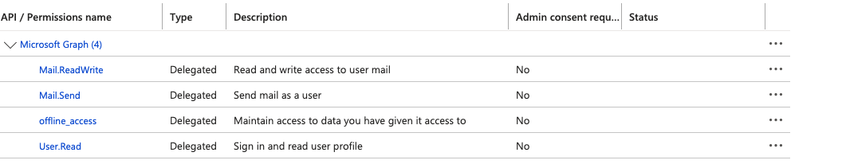
4. Certificates & secrets → New client secret → copy the secret VALUE immediately (it is hidden after you leave the page).
5. In n8n → Credentials → New → "Microsoft Outlook OAuth2 API" → paste Client ID + Client Secret → Connect my account → sign in with the mailbox that should send notifications.
6. Select Any Entra ID Tenant + Personal Microsoft accounts

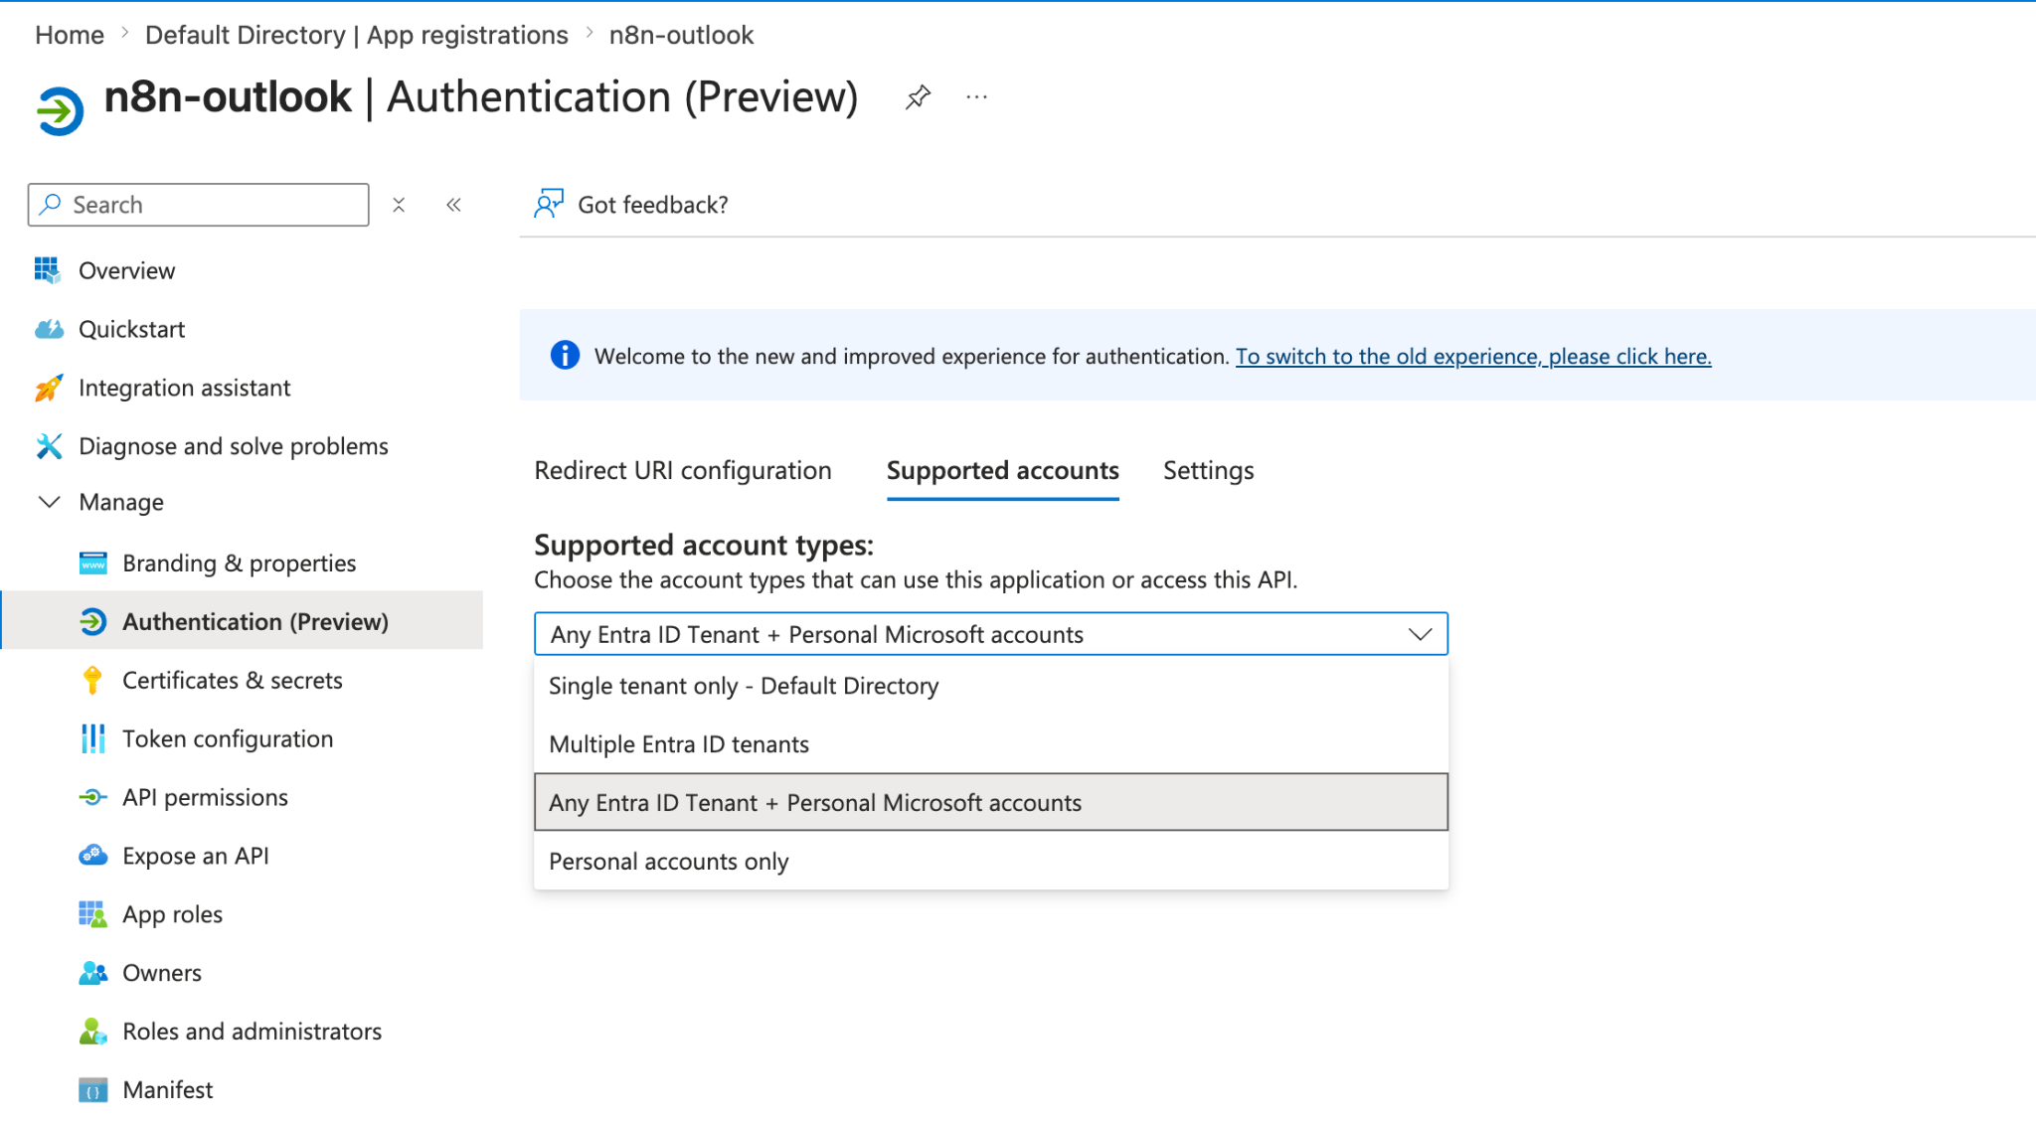

Note: Full step-by-step walkthrough with troubleshooting: Outlook_Setup_Guide.docx

Part F — Bind the Credentials in n8n
In n8n, create these credentials before building the workflow (Outlook only needed for the notification-email variant):
Credential | Fields to fill in
Azure OpenAI | API Key, Endpoint (Resource URL), API Version, Deployment Name (one credential per deployment, or one credential + set deployment per node)
Azure AI Search | Endpoint URL, Admin API Key
Microsoft Outlook OAuth2 (optional) | Client ID, Client Secret, Tenant (leave "common" unless org-restricted)

Test each credential using a simple node (e.g., a Chat Model node pointed at your chat deployment) before moving on. Fixing a bad credential live in front of a class is a bad use of teaching time — verify everything the night before.

Part G — Create the Jira Free Account

G.1 Sign Up (No Credit Card Required)
- Go to atlassian.com/software/jira/free and select "Get it free."
- Sign up with an email address (or Google account).
- Choose a site name — this becomes your-site-name.atlassian.net.
- Pick a project template — "IT Service Management" or a simple "Kanban" project both work for this demo.
Note: The Free plan supports up to 10 users, unlimited projects, and does not expire. Limits: 2 GB storage, 100 emails/day, community support only — none of which affect a classroom demo.

G.2 Generate an API Token
- Go to id.atlassian.com/manage-profile/security/api-tokens (while logged in).
- Create API token → give it a label like n8n-demo → Create.
- Copy the token immediately — it is shown only once.

G.3 What n8n Needs
Field | Where to find it
Site URL | https://your-site-name.atlassian.net
Email | The email you signed up with
API Token | From step G.2
Project Key | Project Settings → Details (e.g., "ITS")

Part H — Cost Control & Cleanup Checklist
Run through this checklist the moment your class ends:
- Delete the entire Resource Group (Portal → Resource groups → select yours → Delete resource group). This removes the Azure OpenAI resource and the AI Search service in one action and stops all billing immediately.
- Regenerate / revoke the Azure OpenAI key and the Jira API token if you plan to reuse the same accounts for a future class.
- Check Cost Management + Billing → Cost analysis to confirm no residual charges.
- Jira Free requires no cleanup — it does not expire and costs nothing to leave running.
Note: Set a personal reminder for day 28 of your Azure trial. If you want to keep the demo alive past 30 days, you must convert to pay-as-you-go before the credit expires, or everything will stop working.

Pre-Class Dry Run Checklist
- [ ] Azure OpenAI credential (API Key, Endpoint, API Version, Deployment Name)
- [ ] Azure AI Search admin key as a Header Auth credential (saved in n8n api-key header)
- [ ] Budget alert configured in Azure
- [ ] Jira credentials copied: API Token, Site URL, Email, Project Key/ID
- [ ] Microsoft Outlook OAuth2 credential connected in n8n: Client ID, Client Secret, Tenant — Mail.Send permission granted + admin consent in Entra ID App Registration (NOT set in Outlook itself)

Screenshot

Resource Group
Azure_ai_search_service_name: n8n-search-rag-demo
azure_openai_resource_name:n8n-project-openAI

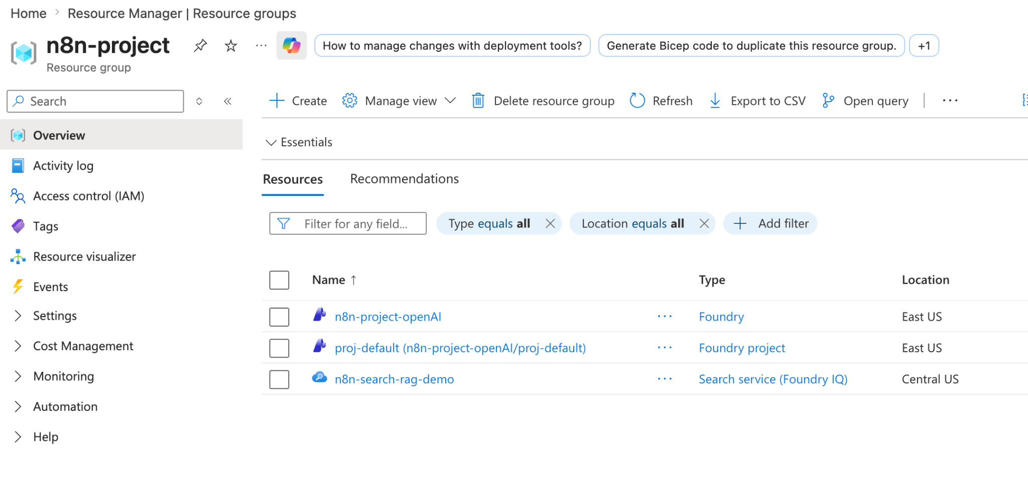
Azure_openai_deployment_name:text-embedding-3-small
azure_openai_api_version:2025-08-07
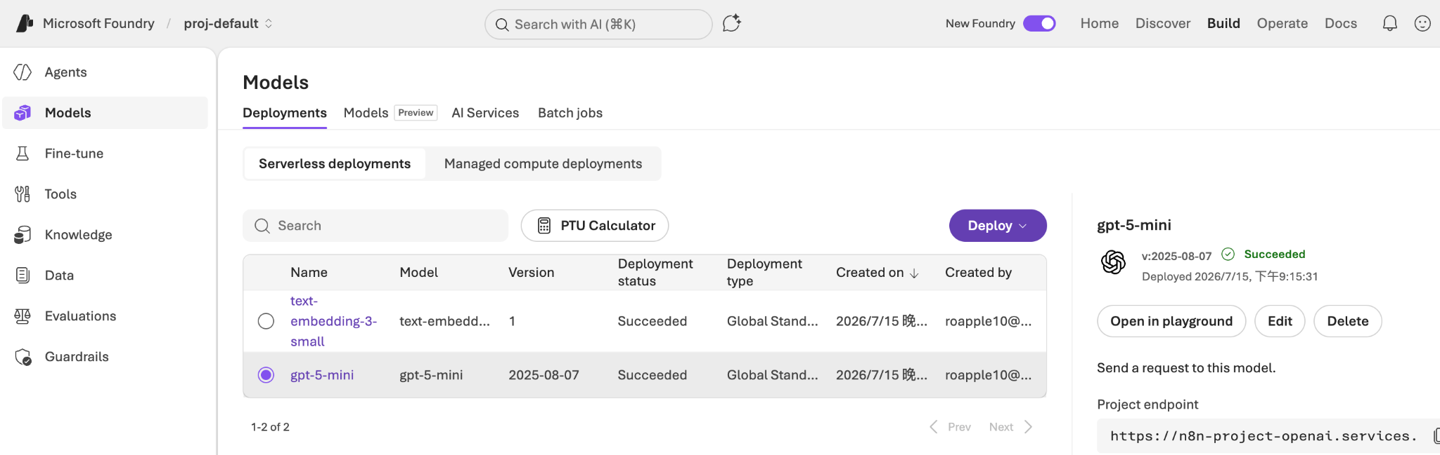

N8N Header Auth account

Value pasted from the Azure AI Search Service Primary admin key

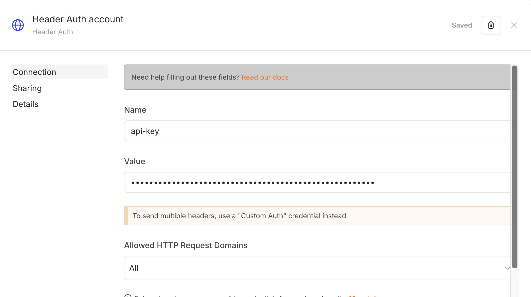
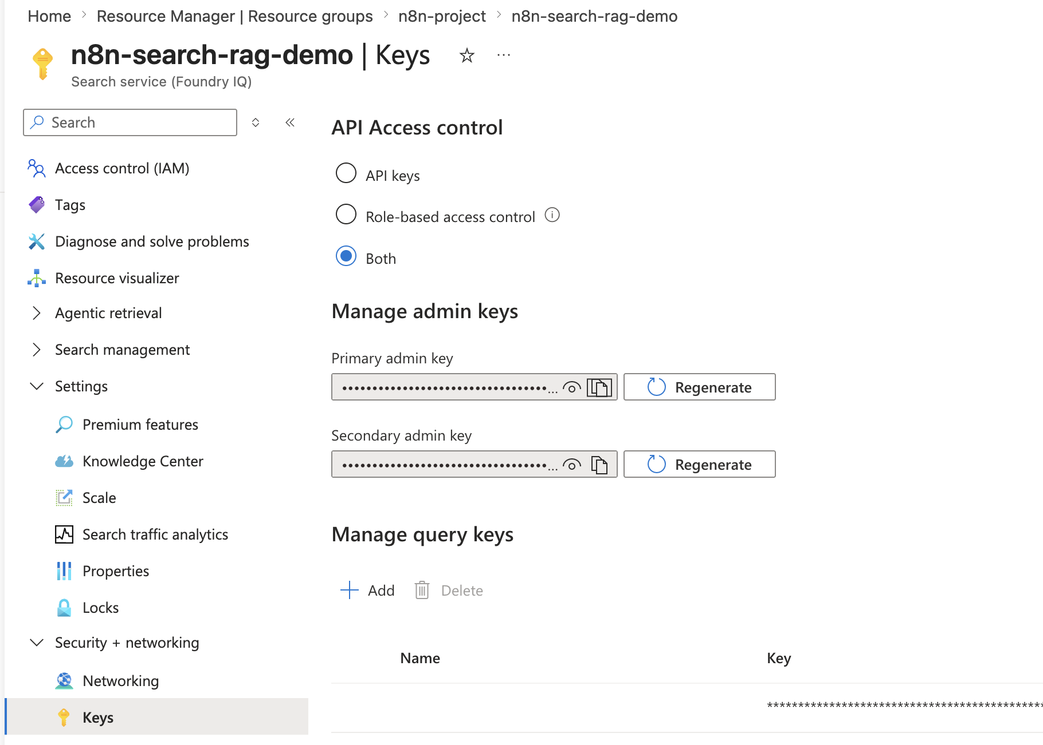

N8N Azure Open AI account

API Key pasted from the Microsoft Foundry API key
Resource Name : n8n-project-openAI
API Version 2025-03-01-preview

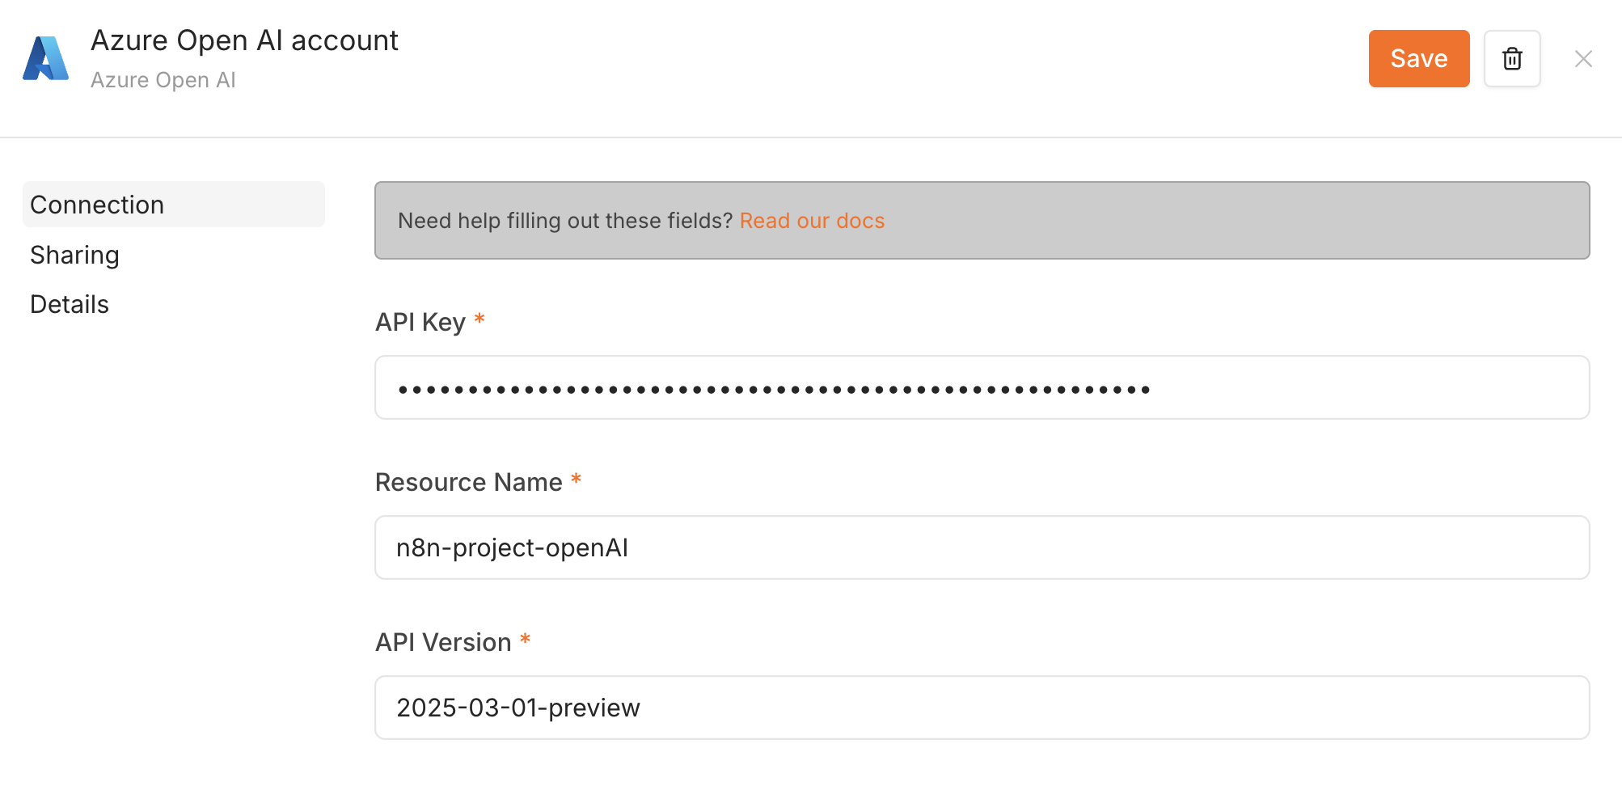
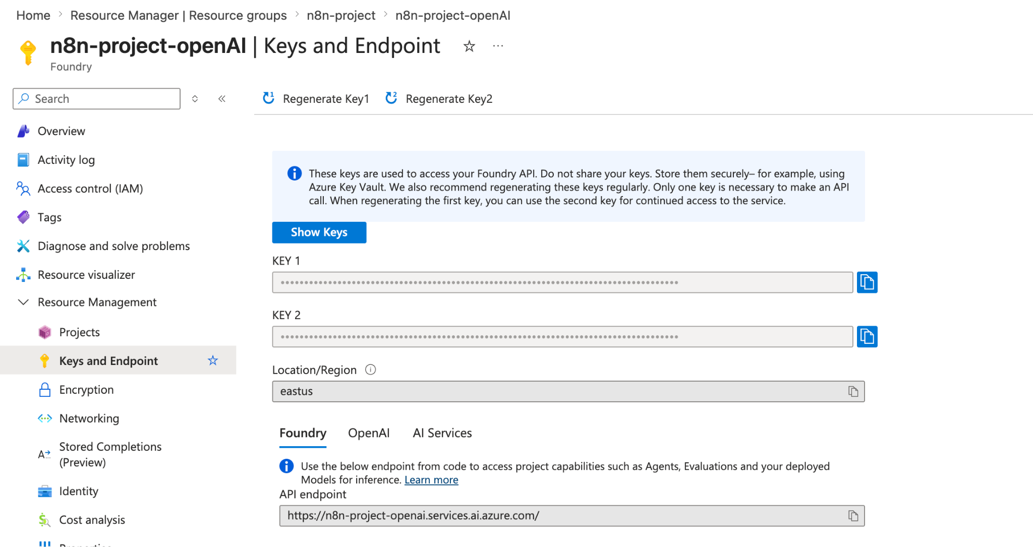

Get-embedding node URL Example :https://n8n-project-openai.openai.azure.com/openai/deployments/text-embedding-3-small/embeddings?api-version=2024-10-21

